AUTUMN END SEMESTER EXAMINATION-2015
5th Semester B. Tech & B. Tech Dual Degree
CO&A (CS-3005)/ CS&A (CS-505)
SOLUTION SCHEME
- Short Questions

Speed of processor is 8 MHz.
Cycle Time=1/(8×10⁶ )
ALU Operation =50%
Memory Operation =30%
Branch Operation=20%
Total Time=(1/(8×10⁻⁶ ))×(50%×4+30%×9+20%×7)sec=7625×10⁻⁶sec

[1000]=J
[1004]=S
- A+B+2

I/O mapped I/O | Memory mapped I/O
Memory and I/O devices will be addressed by the same address. | Memory and I/O can't have same address.
Specialized instructions like IN and OUT are used to communicate with I/O devices. | Same instructions as that of memory operands can be used to communicate with I/O devices.

- Nested sub-routine.

8-bits (Op-code) | 6-bits (Reg-addr) | 18-bits (Mem-addr)
<---------------------------------------------32 bits------------------------------------->
Size of Memory is: 2¹⁸ words=256K words.
- 128K×16=2¹⁷ ×16
Required is 4M×32=2²² ×2×16=2²³ ×16
2²³ ×16=2^{X} ×2¹⁷ ×16
x=6, 2⁶ = 64
- Block size=16 bytes.
No. of blocks in the cache=(128×1024)/16=2¹³
No. of sets=2¹³ /4=2¹¹

SIMD: Single Instruction Stream Multiple Data Stream.
MIMD: Multiple Instruction Stream Multiple Data Stream.

M=010, M'+1=110
A Q Q_{n+1} SC
Initialization 000 101 0 011
SUB M 110 101 0
AShiftR 111 010 1 010
ADD M 001 010 1
AShiftR 000 101 0 001
SUB M 110 101 0
AShiftR 111 010 1 000
So, Product=AQ=111010

- Virtual memory is a technique that allows the execution of processes which are not completely available in memory. The main visible advantage of this scheme is that programs can be larger than physical memory. Virtual memory is the separation of user logical memory from physical memory.
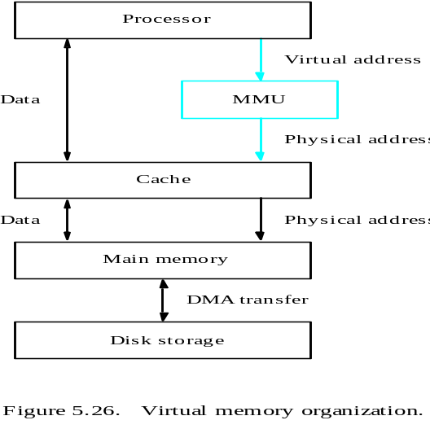
- Address Translation Mechanism:All programs and data are composed of fixed-length units called pages, each of which consists of a block of words that occupy contiguous locations in the main memory. Page cannot be too small or too large. The virtual memory mechanism bridges the size and speed gaps between the main memory and secondary storage. The page table information is used by the MMU for every access, so it is supposed to be with the MMU. However, since MMU is on the processor chip and the page table is rather large, only small portion of it, which consists of the page table entries that correspond to the most recently accessed pages, can be accommodated within the MMU.
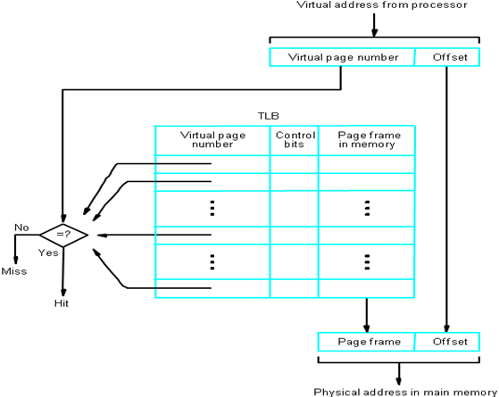
[1+3]

10-bits (Op-code) | 7-bits (Reg-addr) | 28-bits (Mem-addr)
<---------------------------------------------45 bits------------------------------------->
Operations: 2¹⁰ [2 marks]
One address memory operations: (2¹⁰-450) ×2²⁸[2marks]

- Programmed I/O:Once the data is initiated the CPU starts monitoring the interface to see when next transfer can be made. The instructions of the program keep close tabs on everything that takes place in the interface unit and the I/O devices. In this technique CPU is responsible for executing data from the memory for output and storing data in memory for executing of Programmed I/O.
Drawback of the Programmed I/O:The main drawback of the Program Initiated I/O was that the CPU has to monitor the units all the times when the program is executing. Thus the CPU stays in a program loop until the I/O unit indicates that it is ready for data transfer. This is a time consuming process and the CPU time is wasted a lot in keeping an eye to the executing of program. To remove this problem an Interrupt facility and special commands are used.
[2+2]

Hazard:There are situations called hazards that prevent the next instruction in the instruction stream from executing during its designated clock cycles.
Types of hazard
(i) Data Hazard
(ii) Structural Hazard
(iii) Control Hazard
Solutions of Data Hazard
(i) Operand forwarding.
(ii) By s/w (NOP)
(iii)Reordering the instructions.
[1+3]

Direct: 900
Immediate:601
Relative:1502
Register Indirect:100
Index: 1000

14.25=1110.01
Normalized value=1.11001×2³
E ' = 3+127=130=10000010
M=110010 . . . 0
S=0
Special Values:
 | E' | M
0 | 0 | 0
∞ | 255 | 0
NaN | 255 | ≠0
Denormal Number | 0 | ≠0
[2+0.5*4=2]

Control Steps of ADD R1, (R2)

1. PC _{out,} MAR _{in,} Read, Select 4,Add,, Z _{in}
2. Z _{out,} PC _{in ,} Y _{in} ,WMFC
3. MDR_{out} , IR _{in}
4. R2_{out} , MAR_{in} , Read
5. R1_{out}, Y _{in} , WMFC
6. MDR_{out} , Select Y, ADD, Z _{in}
7. Z _{out,} MDR _{in}
8. R2_{out} , MAR_{in} , Write
9. WMFC, End.

Micro routine of ADD R1, (R2)
[1:Fetch,1:Operation,0.5:Writing the result, 1.5 :microroutine]

- In microprogrammed control unit , the logic of the control unit is specified by a microprogram. A microprogram consists of a sequence of instructions in a microprogramming language. These are the instructions that specify microoperations. Microprogram are stored in microprogram memory and the execution is controlled by microprogram counter (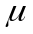PC ) .Microprogram consists of microinstructions which are nothing but the strings of 0’s and 1’s .
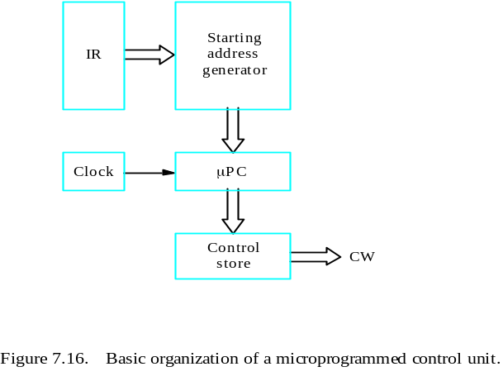

(i) Micro Instruction
(ii) Micro Routine
(iii) Micro Program Counter
(iv) Control Store
[2+0.5*4=2]

- Content-addressable memory (CAM) is a special type of computer memory used in certain very-high-speed searching applications. It compares input search data (tag) against a table of stored data, and returns the address of matching data.

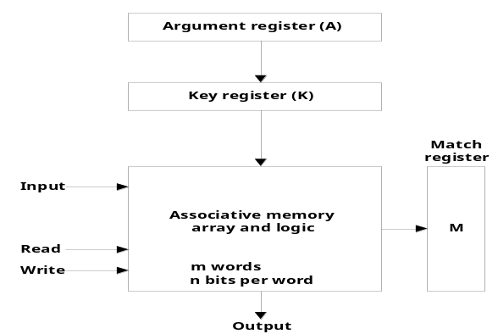

The key register holds a mask that allows searching based on part of argument. If a bit in the key register is 1, then the corresponding bit in the argument and each memory word must be the same to be considered a match. If a bit in the key register is 0, then the corresponding bit is considered a match whether or not the argument and memory word are equal for that bit. This allows searches for words where any subset of the bits match the argument register.

How it is different from RAM?
1. Associative memory unit is accessed by content but RAM is accessed by address.
2. An associative memory is more expensive than RAM because each cell must have storage capacity as well as logic circuit for matching its content with an external argument.
3. Associative memory is used in applications where the search time is very critical and must be very short.
[1+2+1]

(i)
h1=0.7
T_{avg1}=50ns
T_{avg2}=T_{avg1}+20% of 50=50+10=60ns
t1=t2/10
T_{avg}=0.7×t1 + 0.3 × (10×t1)
t1=13.51ns
t2=10×t1=135.1ns
(ii) T_{avg2}=h_{N} × t1+(1- h_{N} ) × t2
60= h_{N} ×13.51+ (1- h_{N} ) × 135.1
h_{N} = 0.61
(iii) Change in hit ratio is=0.7 - 0.61= 0.09
Percentage of change in hit ratio=0.09/0.7×100= 12.85%
[1.5+1.5+1=4]

Vectored Interrupt: A device requesting an interrupt can identify itself by sending a special code to the processor over the bus.

Daisy chain
Simultaneous arrivals of interrupt requests from two or more devices. The processor must have some means of deciding which request to service first.

[2+2]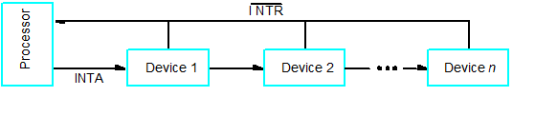

Pipeline Stages Stage Delay(ns) Overhead(ns) T_{clk}
A 9 2 1 : 3ns
B 5 2, 4, 3, 2, 2 1 : 5ns
T_{A} = (9+99)×3ns=324ns
T_{B} = (5+99) ×5ns=520ns
Time saved=(520-324)ns=196ns
OR
Pipeline Stages Stage Delay(ns) Overhead(ns) T_{clk}
A 9 2 : 2ns
B 5 2, 4, 3, 2, 2 1 : 5ns
T_{A} = (9+99)×2ns=216ns
T_{B} = (5+99) ×5ns=520ns
Time saved=(520-216)ns=304ns

[1.5+1.5+1=4]

- Cycle Stealing Vs Burst Mode [2+2]
Cycle Stealing of DMA | Burst Mode of DMA
It is the data transfer technique in which one data word is transferred and then control is returned to CPU. | It is the DMA data transfer technique in which number of data words are transferred continuously until whole data is not transferred.
Data is transferred only when CPU is idle. | Data transfer continues until whole data is not transferred.
It is slow data transfer technique. | It is very fast data transfer technique.
High CPU utilization because data is transferred when CPU has no task to perform. | Low CPU utilization because CPU remains idle until whole data is not transferred.
Extra overhead because every time CPU has to be monitored for idle periods or slots. | No need to check CPU idleness.

- RISC Vs CISC[2+2]
RISC | CISC
Fixed format instruction. | Variable format instruction.
Hardwired ControlUnit Design | Microprogrammed ControlUnit Design.
Pipeline is directly supported. | To support pipeline extra circuitary is reqd.
Less no of addressing modes. | More no of addressing modes.
Large number of registers are used. | Small number of registers are used.

